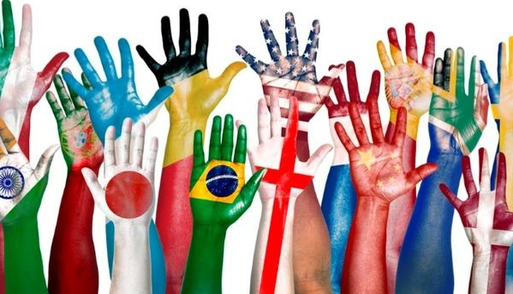
Hosmer’s
International
Night
March 28,
2019

Let Hosmer staff, students, and families teach you about the history, culture, and traditions of countries near and far!

Thursday, March 28, 2019 from 6:00-8:00 PM

Israel | Taiwan | South Korea |  | Russia | France
Canada Ecuador Haiti Peru Austria
Ireland | Greece | Iceland | China | Lebanon | Japan
Also, check out…
- Rambax MIT’s Senegalese drumming ensemble
- Live music performed by Son del Sol
- Bring a dish to the delicious potluck dinner

- Visit the International Night Photo Booth and Book Nook
To sign up to host a country table, bring food or help set up
go to: https://www.hosmerpto.org/events/internationalnight
or scan one of the QR codes below.
If you have questions, email katja.spongberg@watertown.k12.ma.us

Country Table Sign up

International Table Sign up
Volunteer Sign up
Potluck Dinner Sign up
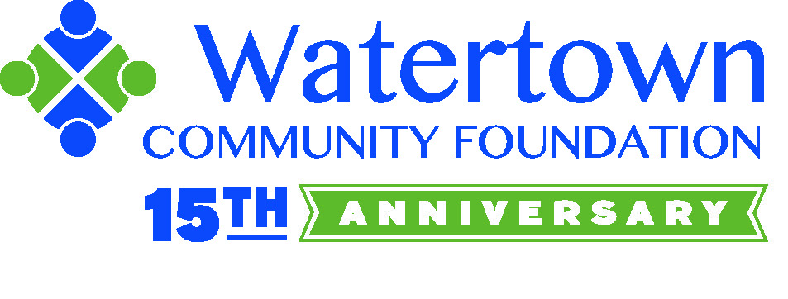
International Night is made possible with funds granted by:
Belmont Savings Bank Foundation, our primary supporter, and the
Watertown Community Foundation

